Digital Wellbeing and Artificial Intelligence
By Gladys Costantia

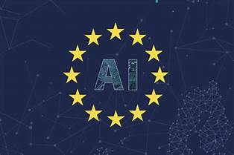

What is artificial intelligence?
Artificial intelligence is any form of task performed by machines which requires human intelligence. In layman terms, Artificial Intelligence can be defined as a branch of computer science that can simulate human intelligence. source

The development of artificial intelligence (AI) is one of the great milestones of recent times. Artificial intelligence which is otherwise called as AI has changed our thought process and has given a diversion to the way we relate to technologies.

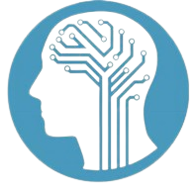

At the industrial level AI has brought in and will continue bringing in tremendous process efficiencies and resource efficiencies resulting in cost, time and resource savings. Businesses can produce better results with lesser manpower. AI provides effective solutions to time management concerns and there are several industries which have benefited from this.

Some examples of industries that are supported by AI are:
Robot Manufacturers
Robots are nothing but machines which performs most of the tasks performed by humans but with greater accuracy. They are devoid at any general intelligence but excel in problem solving.

Medical Industry
AI has proven to be the most efficient and beneficial implementation in the healthcare industry. We have heard about so many robotic surgeries such as surgeries which were of high risk but were performed at ease. Bookkeeping has become simple with the help of AI these days.

Accounts and Finance
Finance, this industry relies on high level accuracy with the given time span. This AI has been able to keep up to the expectations of the industries where the data provide are highly accurate. Finance industry and the AI goes very well hand in hand.

How has it evolved at an individual level?
In the earlier days of mobile phones, we were only able to talk to others with it. But now, smartphones have evolved drastically which makes our lives more comfortable that we are able to interact with our mobiles.

For example, in the past, to solve complicated arithmetic problems applied our minds. Later on, we all slowly started using calculators. Of recent, we don’t even have to open our calculators. Virtual assistants like SIRI, Alexa, Ok google can do the math for us, eliminating the time and effort to open the calculator and do the math. AI has made our lives easy to that extent. Or, is it making us lazy?
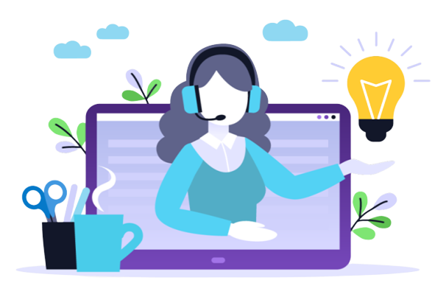

The present world is moving at a raping pace and the people are so busy that people want to save as much time as possible. By extensive usage of the available AI resources people fail to understand how it influences their mental processes. Experts are considering how this transformation will affect the lives of human beings and their process of thinking.

How can AI impact us negatively?
Though AI has supported many industries in terms of improvement, accuracy and reduction in the time and error, it also has many negative impacts such as
- Leads to unemployment/under employment
- Lack of critical/analytical thinking
- Human dominance as AI has the ability to learn and react faster than humans
- High cost in terms of development and maintenance
- Being misused in industries like Military, Education, Healthcare and etc.

Therefore, AI is only a solution to improve efficiency and productivity of work and it is our responsibility to ensure how we use it and why we use it. Excessive usage of AI could severely hinder one’s own capabilities. AI isn’t programmed to guide us when to use it and when to exercise our own judgement. However there could a section of users who will not be able to exercise the judgement. While, as the creators of AI, humans are capable of controlling their minds as well as AI excessive usage could also produce adverse effects. Therefore, we have the responsibility to think for the larger good and implement regulation and control measures to avoid/minimize adverse effects.

According to the EU AI Act, The AI Act is a proposed European law on artificial intelligence (AI) – the first law on AI by a major regulator anywhere. The law assigns applications of AI to three risk categories. First, applications and systems that create an unacceptable risk, such as government-run social scoring of the type used in China, are banned. Second, high-risk applications, such as a CV-scanning tool that ranks job applicants, are subject to specific legal requirements. Lastly, applications not explicitly banned or listed as high-risk are largely left unregulated. Source

How can we connect AI with Digital Wellbeing?
Digital wellbeing is a very important topic of discussion. Digitization can be addictive, spoil the mental health, can affect the personal lives if it is not well balanced. So as humans, we should consider digital wellbeing as a priority to sustain in the long term in the digital world.

Rather than considering AI as a hindrance, we can utilize the support of Artificial Intelligence to monitor and control digital wellbeing. The possible ways are:
- Take the help of Wellbeing monitoring apps which monitors the time spent in social media and control the unwanted time spent in social media.
- Wearable technology like smartwatches which monitors daily activities and gives a report at the end of the day. This can help in controlling stress levels by eliminating unproductive activities or activities that has negative impact on mental health.
- Data gathering and screening are AI tools that helps companies monitor the screen time of their employees, control their activities and keep them focused at work. There are few apps which auto generates an electronic report and keeps employees away from distractions during working hours. Through all these apps employees can monitor his/her screen time, which can result in better time utilization, resulting in avoiding digital stress caused and can possibly avoid long working hours.

The Digital Balance project is a small initiative to create awareness about the importance of digital wellbeing. By sharing the knowledge we gained from the project, we have been able to educate VET Teachers and managers to take better care of the digital wellbeing in their Institutions.

References
https://www.technologyhq.org/
https://www.bbvaopenmind.com/
https://www.pewresearch.org/
https://environmental-conscience.com/
https://www.liberties.eu/

