Digital Wellbeing and Digital Safety
By Gladys Costantia

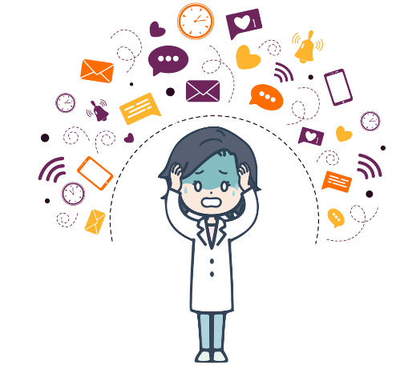

With the proliferation of social media, digital wellbeing has of recent been a topic of discussion often. In 2018, the Digital Security Act (DSA) was introduced as well. We attempt to find out what exactly is digital wellbeing and how to overcome digital stress with some general tips. Subsequently we try to find out how DSA contributes to wellbeing in digital times, without any specific target group in consideration.

What is Digital Wellbeing?
Digital wellbeing is about having a control on digital stress caused by digital exposure to gadgets and technologies. It is really important that one tracks the time spent online and understand how effective the time is spent. This gives the ability to oversee the activities in the digital platform and overcome the consequences caused by digital overload which is caused due to lack of awareness and consequences.

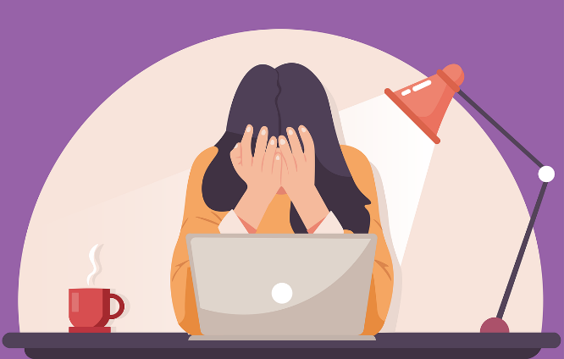

How do we avoid stress caused by Digital overload?
Experts suggest using online platforms wisely to overcome the stress caused by online platforms. Let us get to the details: on a daily basis, an average user switches to minimum of 4-5 apps in the name of relaxation. In the recent era we have multiple apps that are used for entertainment purposes which inadvertently consumes lots of time without any productive results. A strong suggestion to use apps which tracks the time spent in each online platform which at the end of the day will feed you with a summary of the total time you have spent in apps which are used in a productive way and the apps which can be considered time consuming and the user can take initiative to find ways to reduce the time spent in unwanted ways. This practice will save a lot of time and the user also will be able to justify and balance their work life from personal life. Other possible suggestions to be followed to avoid digital strain are as follows:

- Plan your work and work according to your plan
- Take regular breaks to avoid digital overload
- Track the time that you spend in a task and try to shorten it
- Use blue- light filters or reduce the brightness in your gadgets to avoid eye strain.
- Use apps that tracks the time you spend in your mobiles and get it in control

How can you benefit by controlling your online activities?
Work from home has become the new normal and in recent times people find it more convenient to work from home than from office. This new practice has unfortunately resulted in some negative consequences where distraction is caused by various sources. One such strong source of distraction is social media. We intend to use social media and platforms to break from our busy schedule, but we end up losing considerable amount of time that could have been productive otherwise. This digital distraction leads to pile up of tasks which results in increases stress to complete the tasks on time. To avoid the consequences caused by digital distraction one must be able to maintain a positive connection with technology without losing track of time. One should be able to differentiate between the time consumed in a productive way vs time consumed in media which are not useful.

Do’s and Don’t to balance between work life and personal life
Do’s | Don’ts
- Take breaks even during working hours.  - Make sure to take your leave.  - Stay focused to your work during working hours.  - Schedule your day and work according to your schedule. | - Do not work after your working hours.  - Do not work continuously for long hours.  - Plan your leaves ahead to avoid being interrupted during your vacation.

What is Digital Safety?
Digital Safety is the awareness on how to protect your personal information from being misused by any possible source of hack in the new digital world.

Your privacy can be interrupted anytime and your personal details can be stolen and misused for various reasons for which media safety should be prioritize.

Online Crime has become very common. When we talk about online crime it includes online theft. Theft not only means stealing any of your valued possessions. It also means gathering all your personal information.

Naturally, any compromise on digital safety leads to digital stress which has a direct bearing on digital wellbeing and overall wellbeing.

Digital Services Act
The Digital Services Act and Digital Markets Act aim to create a safer digital space where the fundamental rights of users are protected and to establish a level playing field for businesses.

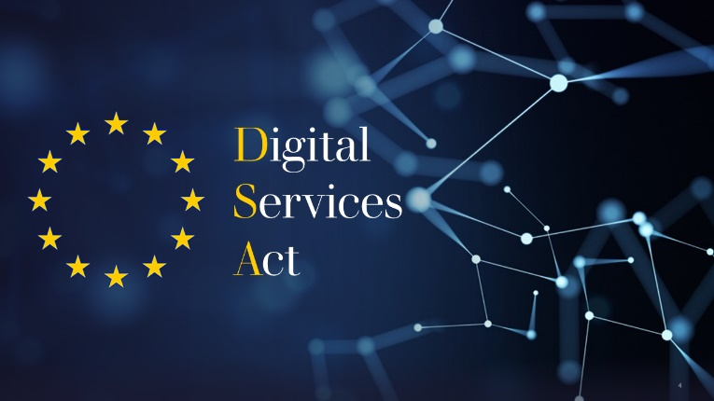

The Digital Services Act (DSA) and the Digital Market Act (DMA) form a single set of rules that apply across the whole EU. They have two main goals:
- to create a safer digital space in which the fundamental rights of all users of digital services are protected;
- to establish a level playing field to foster innovation, growth, and competitiveness, both in the European Single Market and globally.

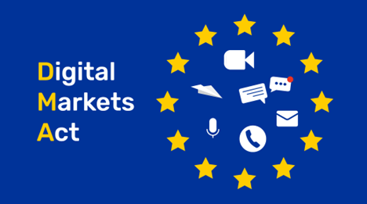

Phishing, cybercrime, online theft, scams via internet and cyberbullying are very common these days. It is every individuals responsibility to make sure to protect their personal information from being misused at any cost.

At an individual level, the following basics could be taken care of, to ensure Digital Safety
- Make sure to always protect your personal information
- Always be alert while online and be careful of your online activities
- Choose Strong passwords and never share your passwords
- Always update your antivirus program
- Practice Safe Browsing
- Never click on random links

Having initiatives from the government and regulators are one side of the solution. Making people aware of such initiatives is what would make the initiatives meaningful. Projects such as Digitalbalance are a small step towards the larger cause. Digital Balance attempts to provide tools and support to help the VET Teachers in particular. Visit the resources of Digitalbalance here and benefit from it.

